Mechanical Design
1.1 3D CAD Model and System Overview
The mechanical design integrates a 6 DOF robotic manipulator onto the mobile chassis using a custom designed payload sled. This configuration maximizes the operational workspace while maintaining navigational capabilities.
This section addresses the Mechanical Design requirements of the PDR, including the 3D CAD model of the robot, the payload sled design files, and an analysis of component placement trade-offs, manufacturability, and structural suitability.
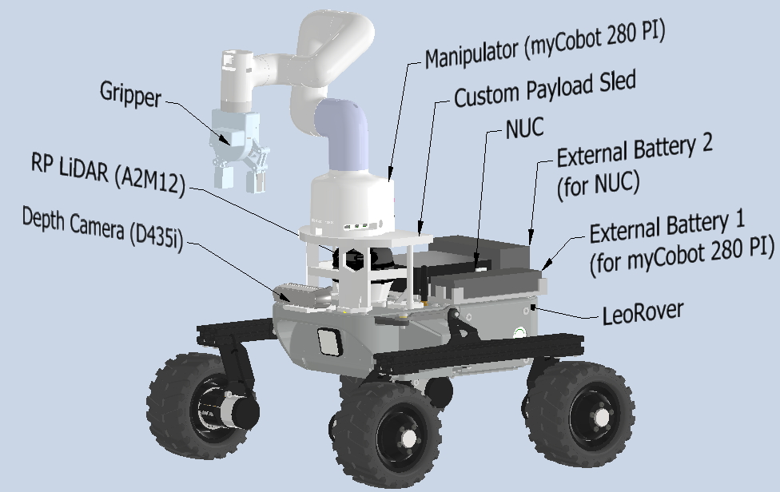  (a) | 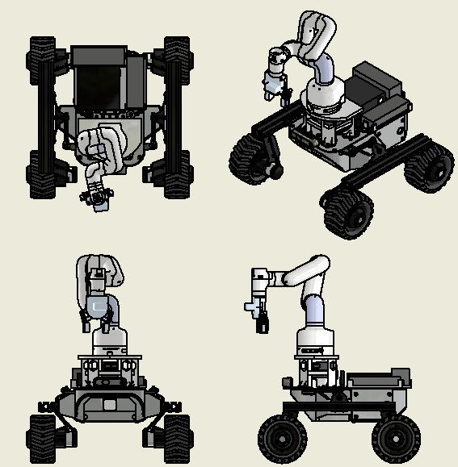  (b)
Figure 1.1: Mobile manipulator platform based on LeoRover. (a) Annotated isometric view identifying key components. (b) Orthographic and isometric views showing the overall geometry.
As illustrated in Figure 3.1, the system features a myCobot 280 PI manipulator mounted on an elevated deck. The RPLidar A2M12 and RealSense D435i are strategically positioned to ensure unobstructed fields of view for autonomous navigation and obstacle avoidance.
1.2 Payload Sled Design Files (https://a360.co/4pViC3t)
The payload sled serves as the central interface, connecting the manipulator and sensors to the rover chassis. A modular design approach was adopted to facilitate assembly and maintenance.
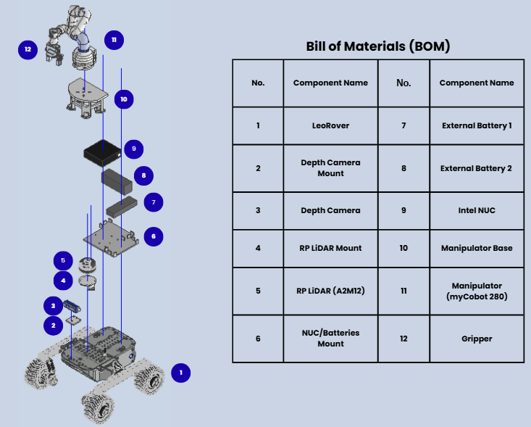
Figure 1.2: Exploded view of the payload sled assembly with Bill of Materials (BOM). (Standard M5 fasteners are omitted from the exploded view for visual clarity. The fastening strategy is described in Section 1.4.)
Figure 1.2 demonstrates the vertical stacking logic. The sled is composed of discrete modules, including the Manipulator Base (Item 10) and sensor/external battery/NUC mounts (Items 2, 4, and 6). The exploded view highlights the assembly axis (indicated by blue trail lines), showing how the 3D printed struts and plates interlock with the chassis via standard M5 fastening points. This modularity ensures that individual components can be rapidly replaced without discarding the entire assembly.
1.3 Component Placement Trade-offs
The arrangement of hardware components involves a critical balance between sensor visibility, mechanical interference, and system stability.
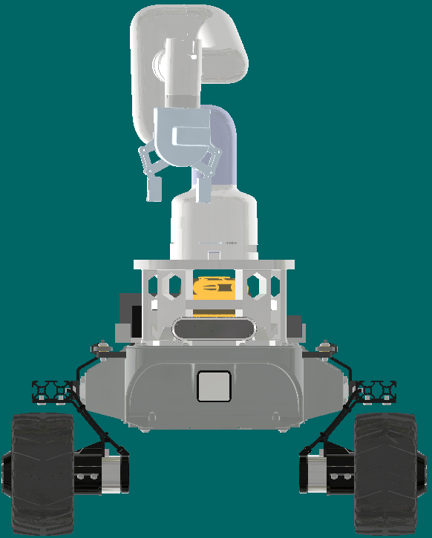  (a) Front/Camera view | 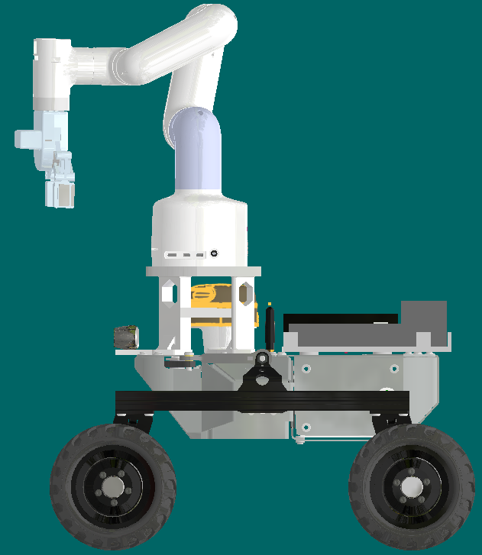  (b) Side view
Figure 1.3: Component placement analysis. (a) Front view showing sensor alignment; (b) Side view illustrating the elevated sensor stack and manipulator.
- Sensor Blocking vs. Mechanical Clearance
As illustrated in Figure 3.3(a) and (b), the primary design challenge was to prevent the sensors (LiDAR and Depth Camera) from obstructing each other or being blocked by the chassis components.
- LiDAR Elevation
The RPLidar is mounted on a raised base. This elevation is strictly necessary to clear the height of the NUC unit positioned at the rear of the rover, ensuring an unobstructed 360-degree Field of View for navigation.
- Manipulator Height Trade-off
A direct consequence of raising the LiDAR is the requirement to elevate the robotic manipulator. If the arm were mounted at the chassis level, its movement would be physically obstructed by the raised LiDAR mount. Therefore, the manipulator was elevated via the custom sled. While this increases the system's total height, it is a necessary sacrifice to resolve the interference between the navigation sensors and the manipulator's workspace.
- Center of Gravity Mitigation
To balance this top-heavy configuration, the heaviest components (the Battery and NUC) are positioned at the lowest section of the rear chassis to act as counterweights, ensuring dynamic stability.
- Sled Geometry Optimization
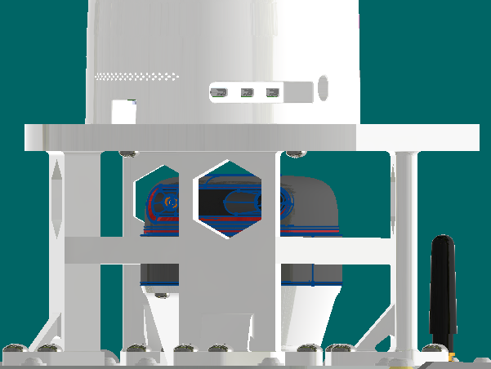  (a) | 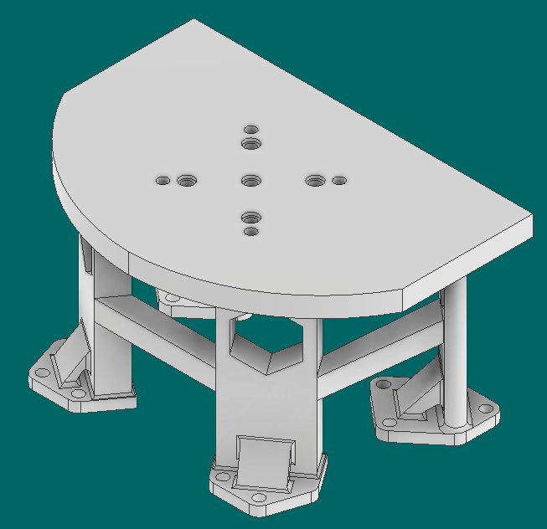  (b)
Figure 1.4 (a) & (b): Detailed view of the custom manipulator base featuring hexagonal cutouts for LiDAR visibility.
The payload sled was meticulously designed to resolve the conflict between the LiDAR's performance and the arm's reach, while also providing a stable structural foundation to support the robotic manipulator mounted above.
- Vertical Clearance
The platform height provides a minimum clearance of 30mm above the LiDAR's scanning plane. This margin accounts for the RPLidar's vertical beam divergence, ensuring the laser is not clipped by the plate. However, the height is strictly capped; raising it further would compromise the center of gravity and prevent the arm from reaching lower targets (e.g., objects on boxes).
- Hexagonal Cutouts
To minimize blind spots in the LiDAR's data, hexagonal cutouts were engineered into the support struts. This reduces the structural cross-section obstructing the 360° scan while retaining sufficient material strength to support the manipulator's dynamic loads.
Overall, the final component layout resolves the conflicts between sensor visibility, manipulator reach, and system stability while staying within the physical constraints of the LeoRover chassis.
1.4 Manufacturability and Suitability Analysis
The payload sled design was optimized for FDM 3D printing (PLA/PETG), prioritizing structural rigidity while adhering to time-and-cost-efficient manufacturing principles.
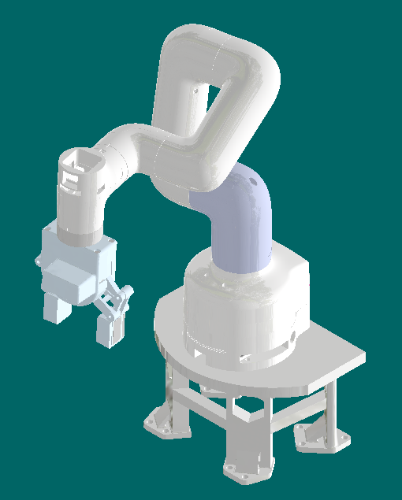  (a) | 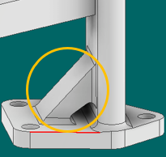 (b)
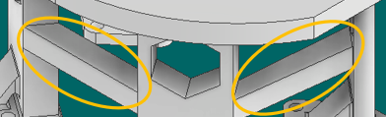
(c)
Figure 1.5: Structural optimization details. (a) Isometric view showing the manipulator integrated onto the sled. (b) Reinforced base struts featuring triangular gussets. (c) Transverse cross-beams connecting the struts to enhance torsional rigidity.
Manufacturability (Design for Additive Manufacturing)
To minimize production costs and lead time, the design strictly follows DfAM (Design for Additive Manufacturing) guidelines:
- Print Orientation & Self-Supporting Geometry: As verified in the slicer software (Bambu Studio), the sled is designed to be printed in an inverted orientation. The hexagonal cutouts and angular struts feature overhangs between 45° and 60°, allowing them to be self-supporting.
- Minimal Support Requirement: This orientation eliminates the need for large internal support structures for the top plate. Support material is restricted solely to the small surface area of the mounting feet overhangs, significantly reducing material waste.
- Tolerance and Print Settings: A dimensional tolerance of +0.2mm was applied to all mounting holes to account for thermal shrinkage, ensuring a seamless fit for fasteners. The parts are specified to be printed with 4 perimeter walls and 40% gyroid infill. This specific infill pattern provides isotropic strength, maximizing the load-bearing capacity while minimizing weight.
Suitability and Structural Integrity
The structural design ensures stability under the dynamic loads of the manipulator, utilizing a reinforced frame architecture:
- Z-Axis Reinforcement (Figure 3.5b): Triangular reinforcement ribs were integrated into the base of the struts. These ribs distribute bending moments over a larger area, mitigating the risk of layer delamination, the most common failure mode in FDM parts loaded laterally.
- Lateral Stability (Figure 3.5c): To prevent structural wobbling during arm acceleration, transverse cross-beams were added to connect the vertical struts. These beams create a rigid frame that resists lateral deflection and torsional forces.
1.5 Justification of Structural Analysis (Fit for Purpose)
- Load Analysis: Given the low total static load applied to the sled, which comprises the myCobot 280's net weight (~850 g) and its maximum payload capacity (250 g), the resulting downward force is approximately 1.1 kg (~11 N). Relative to the sled's structural volume, cross-beam reinforcement, and high infill density, this load is minimal.
- Chassis Connection Interface Analysis: The payload sled is rigidly secured to the Leo Rover's aluminum mounting deck using ten M5 socket head cap screws (see Figure 3.6).
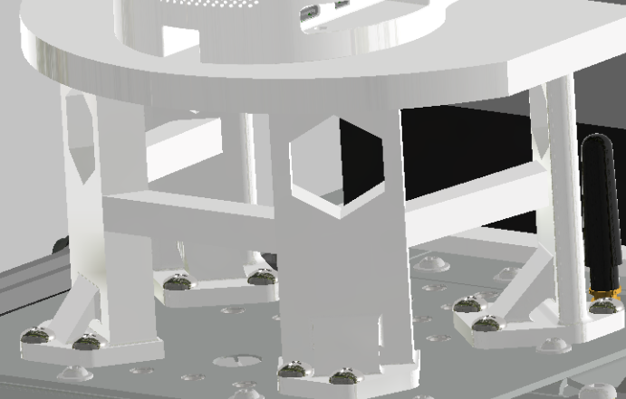
Figure 1.6: Close-up view of the sled base secured to the Leo Rover chassis using ten M5 fasteners.
The use of M5 fasteners is dictated by the rover's standard mounting interface rather than load requirements. A single Grade 8.8 M5 bolt offers a shear strength exceeding 3,000 N. With 10 connection points, the total shear resistance exceeds 30,000 N. Compared to the manipulator's dynamic load (< 50 N), this geometric constraint results in a massive safety factor (>600), rendering the interface virtually fail-proof.
- System Stability & Mass Distribution Strategy: To ensure operational stability, the power configuration serves a dual mechanical purpose. As shown in Figure 1.7, two auxiliary battery units are mounted on the rear chassis deck.
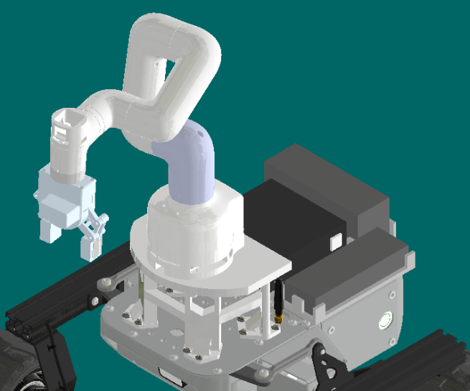  (a) | 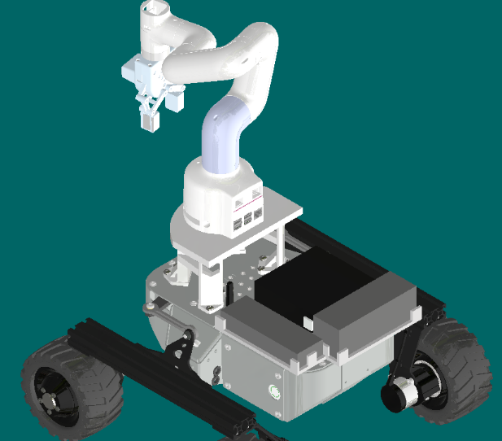  (b)
Figure 1.7 (a) and (b): Rear mounted battery units acting as counterweights to offset the manipulator's reach.
This strategic placement shifts the global Center of Gravity rearward, creating a restoring moment. This effectively negates the forward tipping torque generated when the manipulator is fully extended, ensuring passive stability during pick-and-place operations without the need for active stabilization control.
- Conclusion: Engineering judgment indicates that the current design provides a safety factor well beyond operational requirements for structure, connection, and stability. Therefore, full Finite Element Analysis (FEA) or dynamic tipping simulations would offer diminishing returns and were considered unnecessary for this PDR, in line with efficient engineering practice.

